A
PROJECT PHASE II REPORT
On

Smart Pesticide Application System

Submitted to
MIT Art, Design & Technology University
in partial fulfilment of the requirements for the award of the degree of
BACHELOR OF TECHNOLOGY
IN
ELECTRONICS AND COMPUTER ENGINEERING

Submitted by
Group Code: ECO2526UGP-20
OM PAWAR MITU23BTECD010
ANUJA CHITODE MITU22BTEC0011
ABHISHEK PALVE MITU22BTEC0001
SHRUTI SAWARE MITU22BTEC0090

Under the Guidance of
Prof. Dr. Sachin Patil



DEPARTMENT OF ELECTRONICS AND COMMUNICATION ENGINEERING
MIT SCHOOL OF ENGINEERING AND SCIENCES,
MIT ADT UNIVERSITY RAJBAUG, LONI KALBHOR, PUNE – 412201
May 2026


DEPARTMENT OF ELCTRONICS AND COMMUNICATION ENGINEERING
SCHOOL OF ENGINEERING AND SCIENCES,
MIT ADT UNIVERSITY, RAJBAUG, LONI KALBHOR,
PUNE – 412201

CERTIFICATE

This is to certify that the Project Phase II (21BTCO821R) report entitled
“Smart Pesticide Application System”
Submitted by

OM PAWAR MITU23BTE3CD010
ANUJA CHITODE MITU22BTEC0010
ABHISHEK PALVE MITU22BTEC0001
SHRUTI SAWARE MITU22BTEC0090
is a bonafide work carried out by them, under the supervision of Prof. Dr. Sachin Patil and it is submitted towards the partial fulfilment of the requirement of MIT Art, Design and Technological University, Pune for the award of the Bachelor of Technology in Electronics and Computer Engineering.

Prof. Dr Sachin Patil  Guide | Prof. Poonam Dhole  Project Co-ordinator
Prof. Dr. Sachin Takale  Program Head ,ECO | I/C Head of Department, ECE
Prof. Dr. Sudarshan B. Sanap  Dean, Faculty of Engineering and Sciences | Chairperson / Examiner

Place: Pune
Date: 24/11/2025
DECLARATION
We hereby declare that the project entitled “Smart Pesticide Application System” submitted towards the partial fulfilment of the requirement of MIT-ADT University, Pune for the award of the Bachelor of Technology in Electronics and Computer Engineering, is a record of bonafide work carried out by us under the supervision of Prof.Dr Sachin Patil, Department of Electronics and Communication Engineering, School of Engineering and Sciences.
We further declare that the work reported in this report has not been submitted, and will not be submitted, either in part or in full, for the award of any other degree or diploma in this institute or any other institute or university.

Place: Student Names and Sign
Om Pawar
Anuja Chitode
Abhishek Palve
Shruti Saware
Date:

SPONSORSHIP LETTER (if any)

ACKNOWLEDGEMENT

We express our profound thanks to our Guide Prof. Dr. Sachin Patil, Electronics and Communication Engineering, School of Engineering and Sciences MIT-ADT University, Pune for his/her expert guidance, encouragement and inspiration during this Project Phase I work.
We are very thankful to Prof. Poonam B Dhole, UG Project Co-ordinator, Electronics and Communication Engineering Department for her guidance and all kinds of help to complete my/our work.
We sincerely appreciate to Prof. Mahesh A. Kamthe, PBA Co-ordinator, Electronics and Communication Engineering Department for his guidance and all kinds of help to complete my/our work.
We also express thanks to Prof. Dr. Sachin Takale, Program Head, Electronics and Computer Engineering, for being constant source of inspiration throughout the execution.
We are grateful to Prof. Dr. Sudarshan B. Sanap, Dean, Faculty of Engineering and Sciences, MIT-ADT University, Pune, for providing us the facilities to carry out this work.
We also thank all the faculty members in the department for their support and advice. We are very much grateful to our Parents for their immense love, affection, help, cooperation and encouragement to complete this course.
Finally, we extend our heartfelt thanks to all our classmates and friends for their constant support, guidance, and encouragement throughout the successful completion of our Project Phase II.
Student Names

ABSTRACT
The increasing demand for higher agricultural productivity has led to the widespread use of pesticides; however, traditional methods of pesticide application often result in excessive chemical usage, uneven distribution, and significant health risks to farmers. These conventional practices also contribute to environmental pollution and increased operational costs. To address these challenges, this project presents the design and development of a Smart Pesticide Application System that enables precise, efficient, and automated pesticide spraying.
The proposed system is built using a microcontroller-based platform integrated with sensors such as ultrasonic sensors for obstacle detection and crop identification. The system is mounted on a robotic vehicle capable of navigating agricultural fields autonomously. Based on real-time sensor inputs, the system selectively sprays pesticides only where required, ensuring targeted application and minimizing wastage. Additionally, the system incorporates a control mechanism that maintains uniform spraying and avoids unnecessary exposure to non-target areas.
The work completed includes the design of the hardware setup, integration of sensors, development of control algorithms, and testing of the robotic system in simulated field conditions. The system demonstrated effective obstacle avoidance, accurate detection, and controlled spraying operations.
The findings indicate that the Smart Pesticide Application System significantly reduces pesticide usage, lowers labor effort, and minimizes human exposure to harmful chemicals. It also promotes sustainable farming practices by reducing environmental impact. Overall, this project highlights the potential of automation and sensor-based technologies in transforming traditional agricultural methods into more efficient and eco-friendly solutions.

PHOTOGRAPH OF THE PROJECT

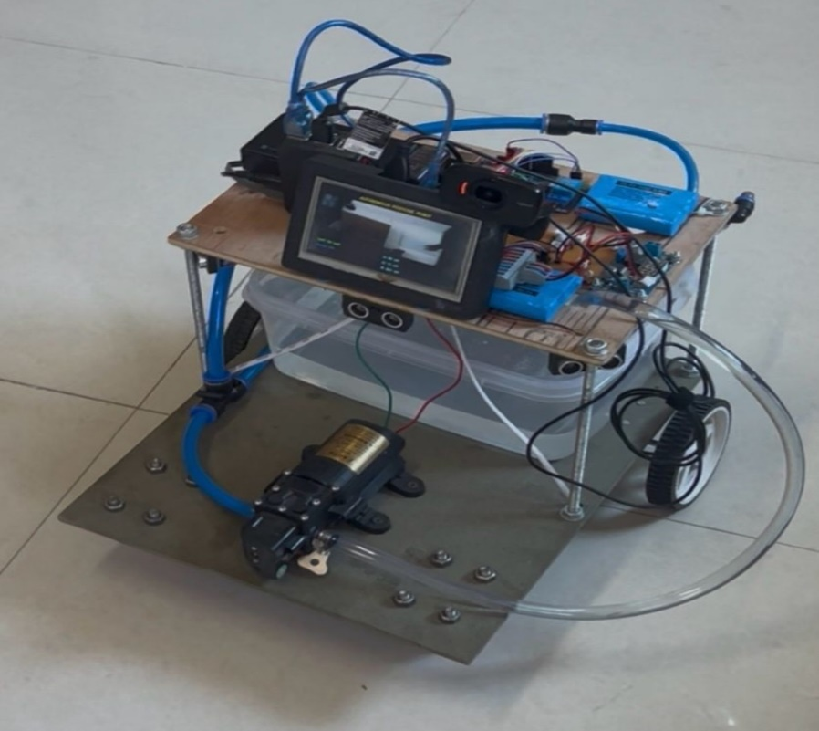

TABLE OF CONTENTS

ABSTRACT i
PHOTOGRAPH OF THE PROJECT ii
TABLE OF CONTENTS iii
LIST OF FIGURES iv
LIST OF TABLES v
ABBREVIATIONS vi
Chapter 1 1
INTRODUCTION 1
1.1 Introduction 1
1.2 Guidelines for Introduction 1
1.3 Organization of the Report 2
1.4 Closure 3
Chapter 2 4
LITERATURE REVIEW 4
2.1 Introduction 4
2.2. Review of literature 4
2.3 Summary of the literature 5
2.4 Identification of Gaps/Scopes of Work 5
2.5 Problem Statement 6
2.6 Objectives 6
2.7 Closure 6
Chapter 3 7
METHODOLOGY 7
3.3 Block Diagram 8
3.4 Closure 8
CHAPTER 4 9
RESULTS AND DISCUSSIONS 9
4.1 Introduction 9
4.2 Key points in Results and Discussion 10
CHAPTER 5 11
CONCLUSION AND FUTURE SCOPE 11
5.1 Conclusion 11
5.2 Future Scope 11
APPENDIX I 13
COST SHEET 13
APPENDIX II 14
PROJECT BASED AWARDS AND ACHIEVEMENTS (if any) 14
PATENT 14
COPY RIGHT 14
LIST OF PUBLICATIONS 14
AWARDS/ACHIEVEMENT IN ANY COMPETITIONS 14
APPENDIX III 15
PROJECT BASED OUTCOMES 15

LIST OF FIGURES
Fig. No. | Name of the Figure | Page No.

LIST OF TABLES
Table No. | Name of the Table | Page No.

ABBREVIATIONS
AI | Artificial Intelligence
Arduino | Open-source Microcontroller Platform
DC | Direct Current
EC | Electrical Conductivity
HC-SR04 | Ultrasonic Sensor Module
IoT | Internet of Things
LCD | Liquid Crystal Display
ML | Machine Learning
Pi | Raspberry Pi
SPS | Smart Pesticide System
OS | Operating System
GUI | Graphical User Interface

Chapter 1

INTRODUCTION

Introduction
The Smart Pesticide Application System focuses on improving the efficiency of pesticide application in agriculture, especially in grape cultivation. Traditional methods rely on manual monitoring and spraying, which are time-consuming, less accurate, and may lead to excessive use of chemicals. This not only increases costs but also affects the environment and human health.
To overcome these challenges, the proposed system uses image-based machine learning to detect plant diseases at an early stage. A camera captures images of grape leaves, and a Raspberry Pi processes these images to identify infections accurately. Early detection helps in taking timely action and prevents the spread of diseases.
Once a disease is detected, the system automatically activates a controlled spraying mechanism to apply pesticide only to the affected area. This targeted approach reduces chemical usage and improves efficiency.
The main aim of this project is to develop an automated and intelligent system that minimizes manual effort, reduces pesticide wastage, and enhances crop protection.

1.2 Guidelines for Introduction

Start broadly and then narrow down
ii. State the aims and importance
iii. Cite thoroughly but not excessively
iv. Avoid giving too many citations for one point
v. Clearly state either your hypothesis or research question
vi. Consider giving an overview of the report
vii. Keep it short
viii. Don't bury your readers in detail

1.3 Organization of the Report
This report presents the design and development of the Smart Pesticide Application System, structured into five chapters to provide a clear and systematic understanding of the project.
Chapter 1: Introduction
This chapter introduces the concept of smart agriculture and highlights the challenges associated with traditional pesticide application methods, such as excessive chemical usage, health hazards, and environmental impact. It explains the need for an automated and precise pesticide spraying system and outlines the objectives and scope of the project.
Chapter 2: Literature Review
This chapter presents a detailed review of existing research and technologies related to automated pesticide spraying systems, agricultural robots, and sensor-based applications in farming. It summarizes previous work, compares different approaches, and identifies the limitations in current systems. Based on this analysis, the research gap is identified, and the objectives of the present project are clearly defined.
Chapter 3: Methodology
This chapter describes the experimental methodology and system design used in the project. It includes details of hardware components such as the microcontroller, ultrasonic sensor, spraying mechanism, and robotic platform. It also explains the working principle, system architecture, flow of operation, and software implementation used to control the system.
Chapter 4: Results and Discussion
This chapter presents the results obtained from testing and implementation of the system. It evaluates the performance of the robot in terms of obstacle detection, navigation, and pesticide spraying efficiency. The results are analyzed and discussed to demonstrate the effectiveness, accuracy, and advantages of the proposed system.
Chapter 5: Conclusion and Future Scope
This chapter concludes the work by summarizing the outcomes and key findings of the project. It highlights how the system improves efficiency, reduces pesticide usage, and enhances safety. The chapter also suggests future improvements, such as integrating IoT, AI-based pest detection, and mobile app control for advanced functionality.

1.4 Closure
This chapter introduced the concept of the Smart Pesticide Application System and highlighted the limitations of traditional pesticide spraying methods, such as excessive chemical usage, uneven distribution, health hazards to farmers, and environmental pollution. The need for an automated, efficient, and precise pesticide application system was clearly established. Additionally, the objectives and scope of the project were defined to provide a clear direction for the work.
The chapter successfully lays the foundation for the development of a smart and sustainable solution in the field of agriculture. It emphasizes the importance of integrating modern technologies such as sensors and automation to improve productivity and reduce harmful impacts.

Chapter 2

LITERATURE REVIEW

2.1 Introduction
This chapter presents a brief review of existing technologies related to automated pesticide application and smart agriculture. Various research works focus on the use of robotic systems, sensors, and camera-based monitoring techniques to analyze crop conditions and improve farming efficiency. Technologies such as RGB cameras, laser sensors, and IoT-based systems are used to collect data like crop health, soil parameters, and environmental conditions, helping in better decision-making for fertilizer and pesticide application.
However, most of the existing systems have limitations such as lack of accurate disease detection, excessive pesticide spraying, and dependency on manual monitoring. These issues highlight the need for a smart and automated system that can detect crop diseases early and apply pesticides only where required. Therefore, the proposed system focuses on integrating image-based disease detection with a robotic spraying mechanism to improve efficiency, reduce chemical usage, and support sustainable agriculture.

2.2. Review of literature
A literature review is an important part of research that provides an overview of existing knowledge, methodologies, and findings related to a specific topic. It helps in understanding previous work, identifying suitable techniques, and establishing a strong foundation for the current study. Literature reviews are secondary sources and provide context for the research by analyzing previously published work.
In the context of the Smart Pesticide Application System, several research papers have contributed to advancements in smart agriculture. Christyan Cruz Ulloa, Anne Krus, Antonio Barriento, Jaime del Cerro, and Constantino Valero (2022) presented work on “Trend Technologies for Robotic Fertilization Process in Row Crops”, which focuses on the use of laser sensors and RGB/multispectral cameras for crop analysis. M.F. Saaid, MK Nordin, Ahmad Ihsan Mohd Yassin, and Nooritawati Md Tahir worked on “Automated Fertilizer Mixer System for Fertigation Farming” to improve fertilizer mixing efficiency. Omer Mohamed Elhassan Ahmed, Abdalla A. Osman, and Sally Dafaalla Awadalkarim proposed “Automated Fertigation System Using IoT”, which focuses on controlling soil parameters such as pH and electrical conductivity.
These studies show significant progress in automation and monitoring in agriculture; however, limitations such as lack of precise disease detection and targeted pesticide spraying still exist. Hence, the proposed system focuses on integrating image-based disease detection with automated and selective pesticide application to improve efficiency and reduce chemical usage.
2.3 Summary of the literature
The reviewed literature focuses on the use of advanced technologies such as robotic systems, camera-based monitoring, and IoT-based automation in agriculture. Techniques like RGB and multispectral imaging, laser sensing, and automated fertigation systems are used to analyze crop conditions and control agricultural inputs. Some systems also utilize sensors to monitor soil parameters like pH and electrical conductivity for efficient farming operations.
The key parameters considered in the literature include crop health indicators (such as leaf condition ), and environmental factors. Imaging parameters like NDVI values, RGB histograms, and point cloud data are also used for crop analysis and decision-making in automated systems.
The literature indicates that automation and sensor-based technologies significantly improve agricultural efficiency and reduce manual effort. However, most existing systems lack precise disease detection and targeted pesticide spraying, leading to excessive chemical usage. These limitations highlight the need for a smart system that can detect diseases accurately and apply pesticides only where required, which is addressed in the proposed project.

2.4 Identification of Gaps/Scopes of Work
From the reviewed literature, several limitations are observed in existing systems. Manual monitoring of grape leaves is time-consuming and inefficient, especially for large farms. Early detection of grape leaf diseases is difficult using traditional methods, leading to delayed treatment. Additionally, most systems apply pesticides uniformly across the field, resulting in excessive chemical usage and increased environmental impact.
To overcome these limitations, the proposed system uses a Raspberry Pi-based image processing approach combined with machine learning for early disease detection in grape leaves. A robotic platform is integrated to automatically navigate the field and monitor crops. The system enables targeted pesticide spraying, where chemicals are applied only to affected areas, ensuring precision and efficiency.
The proposed approach improves existing methods by reducing manual effort, minimizing pesticide overuse, and enhancing detection accuracy through image-based analysis. It also promotes automation and precision farming

2.5 Problem Statement
Manual monitoring of crops and traditional pesticide spraying methods are inefficient, time-consuming, and lead to excessive chemical usage. Early detection of plant diseases is difficult, resulting in delayed treatment and reduced crop quality. There is a need for an efficient system to ensure timely detection and precise application of pesticides while minimizing waste and environmental impact.

2.6 Objectives
• To automate pesticide spraying using a sensor and Raspberry Pi–based control system.
• To detect crop diseases using image processing techniques.
• To apply pesticides precisely only to affected areas to reduce chemical usage.
• To minimize manual labour and reduce health risks to farmers.

2.7 Closure
This chapter presented a comprehensive review of existing literature related to smart agriculture, automated spraying systems, and sensor-based crop monitoring. It highlighted various methodologies such as camera-based detection, IoT systems, and robotic applications used to improve agricultural efficiency. Based on the review, key gaps such as lack of precise disease detection, excessive pesticide usage, and dependency on manual monitoring were identified. The problem statement and objectives of the proposed system were also clearly defined.

Chapter 3

METHODOLOGY
3.1 Introduction
This chapter presents the methodology adopted for the development of the Smart Pesticide Application System. The system is designed to automate the process of crop monitoring and pesticide spraying using a combination of image processing, sensors, and a robotic platform. A camera is used to capture images of grape leaves, and a Raspberry Pi processes these images using a machine learning model to detect plant diseases.
3.2 Methodology details
The methodology of the Smart Pesticide Application System is based on a combination of experimental and computational approaches. The system integrates hardware components such as Raspberry Pi, Arduino Uno, camera module, ultrasonic sensor, motors, relay, and a pesticide pump. A robotic platform is developed to enable movement in the agricultural field, allowing the system to perform automatic monitoring and spraying operations.
In the next stage, image processing is carried out using a camera connected to the Raspberry Pi. The captured images of grape leaves are analyzed using a machine learning model to detect the presence of diseases. This computational process helps in identifying infected areas accurately and at an early stage, improving the effectiveness of pest control.
Once a disease is detected, the system activates the pesticide spraying mechanism. The Raspberry Pi sends signals to the Arduino Uno, which controls the relay and pump system to spray pesticides only on the affected plants. The ultrasonic sensor is used for obstacle detection, ensuring safe navigation of the robot in the field.
The system operates in a continuous cycle of image capture, disease detection, decision-making, and targeted spraying. The entire setup is tested under controlled conditions to evaluate its performance in terms of accuracy, efficiency, and automation. This methodology ensures reduced pesticide usage, minimal human effort, and improved agricultural productivity.

3.3 Block Diagram
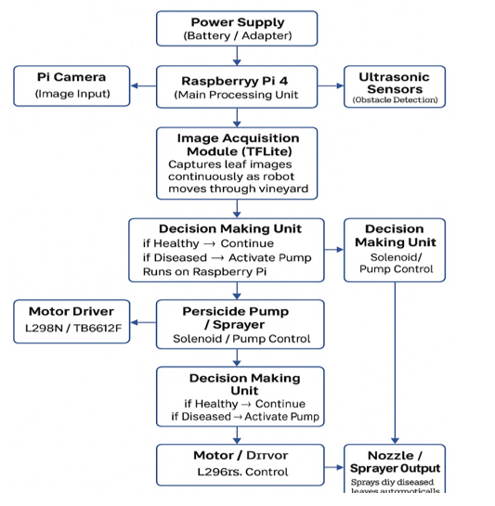
The block diagram of the Smart Pesticide Application System consists of key modules such as the camera, Raspberry Pi, Arduino Uno, sensors, motor system, and spraying unit. The camera captures images of grape leaves, which are sent to the Raspberry Pi for processing. The Raspberry Pi analyzes the images using a machine learning model to detect the presence of diseases.
Based on the detection results, the Raspberry Pi sends control signals to the Arduino Uno. The Arduino acts as the main controller for hardware operations, including controlling the motors for robot movement and managing the spraying mechanism. The ultrasonic sensor is used to detect obstacles in the path, allowing the robot to move safely in the field.
When a diseased leaf is identified, the Arduino activates the relay module, which turns on the pesticide pump. The pump sprays pesticide only on the affected area, ensuring targeted application. The system operates continuously by capturing images, processing data, and performing actions automatically, making the overall process efficient and reducing manual effort.

3.4 Closure
This chapter explained the methodology, system design, and working of the Smart Pesticide Application System, including hardware integration and image-based disease detection for targeted spraying.

CHAPTER 4

RESULTS AND DISCUSSIONS

4.1 Introduction
This chapter presents the results obtained from the implementation of the Smart Pesticide Application System and discusses its performance. The system is evaluated based on parameters such as disease detection accuracy, obstacle detection, navigation efficiency, and effectiveness of targeted pesticide spraying.
The results are analyzed in a quantitative manner using observed data from testing under controlled conditions. The performance of individual components such as the camera, Raspberry Pi processing, ultrasonic sensor, and spraying mechanism is also assessed. This chapter provides a clear understanding of how effectively the system meets the objectives of reducing pesticide usage, minimizing manual effort, and improving precision in agricultural practices.

4.2 Key points in Results and Discussion
i. The results should be presented in a clear and logical sequence, such as disease detection → robot movement → spraying action.
ii. Only the actual findings from your system testing (e.g., detection working, spraying response) should be included.
iii. Focus on results related to your objectives, such as accuracy of disease detection, reduction in pesticide usage, and automation efficiency.
iv. Present data using figures like system output images, tables for observations, and charts showing performance (e.g., detection accuracy or response time).
v. Analyze the results by explaining how the system performed in real or simulated conditions and how effectively it achieved targeted spraying.
vi. Compare your results with existing systems from literature (e.g., traditional spraying vs. your targeted spraying approach).
vii. Include basic performance details such as response time, detection success rate, or any measurable parameter (even simple percentages).
viii. Discuss limitations such as detection errors, lighting conditions affecting camera performance, or navigation issues.
ix. Clearly explain the novelty of your system, such as image-based detection with targeted pesticide spraying using a robot.
x. Avoid repeating the same data or over-explaining; keep the discussion focused, relevant, and based on actual results only.

CHAPTER 5

CONCLUSION AND FUTURE SCOPE

5.1 Conclusion
The Smart Pesticide Application System successfully demonstrates the use of automation and image-based disease detection for efficient agricultural practices. The system is capable of identifying plant diseases using a Raspberry Pi and applying pesticides precisely through a controlled spraying mechanism. The results show that the system reduces excessive pesticide usage, minimizes manual effort, and improves safety by reducing human exposure to harmful chemicals. Overall, the project proves to be a feasible and effective solution for smart and sustainable farming, with potential for further enhancement and real-time implementation.

5.2 Future Scope
This chapter summarized the overall work and key findings of the Smart Pesticide Application System, highlighting its effectiveness in disease detection, automated spraying, and reduction of pesticide usage.

REFERENCES
[1] | Rajendra Prasad et al., “Camera-Based Pest Detection and Robotic Targeted Spraying System for Smart Agriculture,” 2021.
[2] | D. Meena et al., “Microcontroller-Based Automated Pesticide Sprayer Using Motorized Agricultural Vehicle,” 2023.
[3] | Omer Mohamed Elhassan Ahmed, Abdalla A. Osman, Sally Dafaalla Awadalkarim, “Automated Fertigation System Using IoT,” 2020.

Web References
[1] | https://www.researchgate.net/publication/397446351_Smart_Pesticide_Spraying_Robot
[2] | https://www.ijraset.com/research-paper/smart-pesticides-spraying-robot

APPENDIX I

COST SHEET
Sr. No. | Particular | Amount (Rs.)
 | Raspberry Pi 4(4GB) | 4,872
 | Raspberry Pi 4 Power Supply | 635
 | 5 TET LCD | 2,118
 | DC 5V Ultrasonic module,12v Battery Pack,12v-5v converter, HC-SR04 Ultrasonic module | 2,740
 | 12v Motor, Driver module, Wheels, Caster wheel | 1,910
 | Motor, Push Button, Zero pcb servo | 660
 | 12*8 PU Unequal union (4) | 160
 | 80D PU Elbow &80D Inline hand | 225
 | PU Tube &PU equal Tee 8-OD | 90
 | Webcam | 1,200
Total |  | 14,610

APPENDIX II

PROJECT BASED AWARDS AND ACHIEVEMENTS (if any)
The student need to attach the testimonials of the achievement obtained for the project work at the end of the Appendix II.

PATENT
The students need to write the patent details and attach the testimonial for the same (if any). NIL.

COPY RIGHT
The students need to write the copyright details and attach the testimonial for the same (if any). NIL.

LIST OF PUBLICATIONS
The students need to write the publications details in IEEE format and attach the entire paper in the final report for the same (if any). NIL.

AWARDS/ACHIEVEMENT IN ANY COMPETITIONS
The students need to write the details of any awards/achievement received relevant to the project work along with the photograph (if any). NIL.

APPENDIX III

PROJECT BASED OUTCOMES
The student need to fill the below table for the outcomes they have gained during the work. These outcomes will vary based on Project Based Learnings.
Outcomes | Agree  (1) | Moderately  (2) | Highly Agree (3)
1. Engineering knowledge: Apply the knowledge of mathematics science engineering fundamentals and a mathematics, science, engineering fundamentals, and an engineering specialization to the solution of complex engineering problems engineering problems.
2. Problem analysis: Identify, formulate, review research literature, and analyse complex engineering problems reaching substantiated conclusions using first principles of mathematics, natural sciences, and engineering sciences.
3. Design/development of solutions: Design solutions for complex engineering problems and design system components or processes that meet the specified needs with appropriate consideration for the public health and safety, and the cultural, societal, and environmental considerations
4. Conduct investigations of complex problems: Use research-based knowledge and research methods including design of experiments, analysis and interpretation of data, and synthesis of the information to provide valid conclusions
5. Modern tool usage: Create, , select, and apply appropriate techniques, resources, and modern engineering and IT tools including and modelling to complex engineering activities with an understanding of the limitations
6. The engineer and society: Apply reasoning informed by Apply reasoning informed by the contextual knowledge to assess societal, health, safety, legal and cultural issues and the consequent responsibilities legal and cultural issues and the consequent responsibilities relevant to the professional engineering practice
7. Environment and sustainability: Understand the impact of the professional engineering solutions in societal and environmental contexts, and demonstrate the knowledge of, and need for sustainable development and need for sustainable development.
8. Ethics: Apply ethical principles and commit to professional ethics and responsibilities and norms of the engineering practice
9. Individual and team work: Function effectively as an individual and as a member or leader in diverse teams and individual, and as a member or leader in diverse teams, and in multidisciplinary settings
10. Communication: Communicate effectively on complex engineering activities with the engineering community and with society at large, such as, being able to comprehend and write effective reports and design documentation, and write effective reports and design documentation, make effective presentations, and give and receive clear instructions
11. Project management and finance: Demonstrate knowledge and understanding of the engineering and knowledge and understanding of the engineering and management principles and apply these to one’s own work, as a member and leader in a team, to manage projects and in multidisciplinary environments.
12. Life-long learning: Recognize the need for and have the Recognize the need for, and have the preparation and ability to engage in independent and lifelong learning in the broadest context of technological change

